Scientific Method: Module 1
“An experiment should be conducted for a particular reason. A statement which explains what the experiment is attempting to achieve is known as an aim. The prediction that the scientist makes who is undertaking the experiment is known as the hypothesis. In this section you will learn how to construct both an aim and a hypothesis for experiment.”

Instructions
- Enter the following address into your browsers URL: holmesclassrooms.weebly.com/lesson-2.html
- Click on Module 1: Aim and Hypothesis
- Use the information in module one to complete the worksheet below.

Aim
In your own words, write down what an aim is:
__________________________________________________________________________________
__________________________________________________________________________________

Write down an aim for the example questions:
Example 1: ________________________________________________________________________
__________________________________________________________________________________
Example 2: ________________________________________________________________________
__________________________________________________________________________________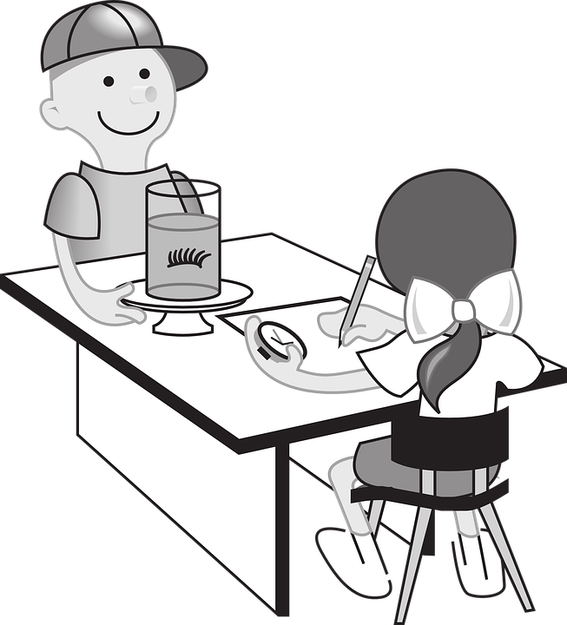

Hypothesis
In your own words, write down what a hypothesis is:
__________________________________________________________________________________
__________________________________________________________________________________

Guidelines for Writing Hypothesis (fill in the blanks).
- A hypothesis ___________ ______ what will happen.
- A hypothesis contains an "_______... ___________..." statement.
- A hypothesis is not ___________________________________________________________.
- A hypothesis is not a statement of __________________________________.
- A hypothesis is not a __________________.
- The more _____________ and _______________ a hypothesis is, the stronger it is.
- A hypothesis must be ______________________.

Complete the hypothesis for Mr. Holmes’ vinegar and bicarbonate soda experiment.
If Mr. Holmes ______________________________________________________________________,
then _____________________________________________________________________________.

Write down a hypothesis for the examples provided:
Example 1: ________________________________________________________________________
__________________________________________________________________________________
Example 2: ________________________________________________________________________
__________________________________________________________________________________
Example 3: ________________________________________________________________________
__________________________________________________________________________________
Example 4: ________________________________________________________________________
__________________________________________________________________________________

